**Rotation, Scaling, Translation of Matrices**

MATHEMATICS FOR COMPUTER GRAPHIC

FINAL REPORT FOR MINI-PROJECT

GROUP 12

|  |  |  |
| --- | --- | --- |
| LAU LI XUAN | A20EC3002 | SECTION 2 |
| LIM ZHEN DONG | A20EC0236 | SECTION 2 |
| ABDULLAH NAFIS | A20EC4060 | SECTION 2 |

**TABLE OF CONTENTS**

|  |  |  |
| --- | --- | --- |
| No. | Title | Page |
| 1 | Introduction | 3 |
| 2 | Program Screenshots | 3 |
| 3 | Output Screenshots | 9 |
| 4 | Conclusion | 11 |

**Introduction**

Matrix is useful for calculating the result of a shape under rotation, scaling, or translation. Trying to figure out how these transformations occur by reading texts can sometimes be confusing and dull. It is better to show these transformations with an interactive visual aid. Therefore, we have developed a tool that allows user to input the coordinate of a triangle’s vertices and select a transformation to observe how the shape changes. We believe that this tool could help someone to learn the transformation of matrices interestingly so he or she can easily understand the concept.

**Programs Screenshots**

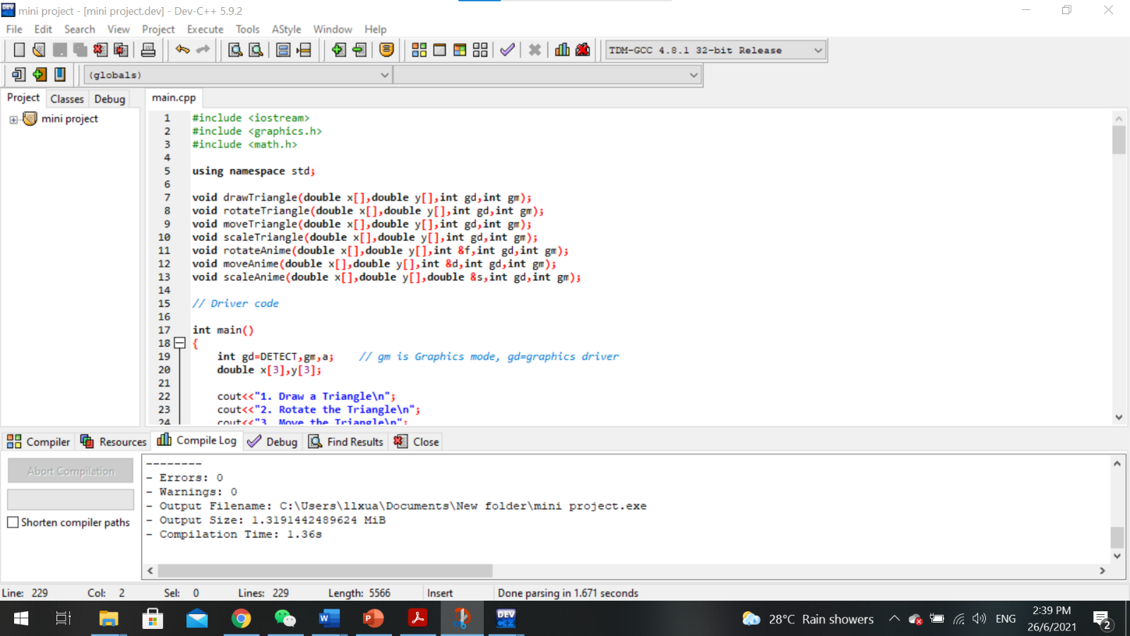

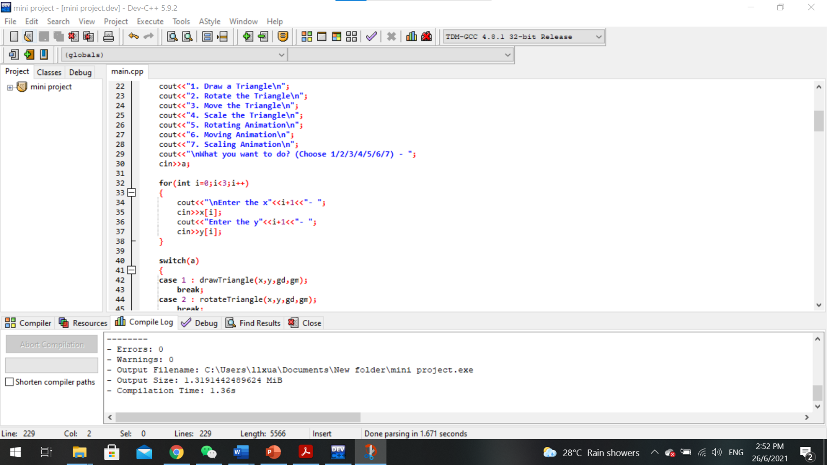

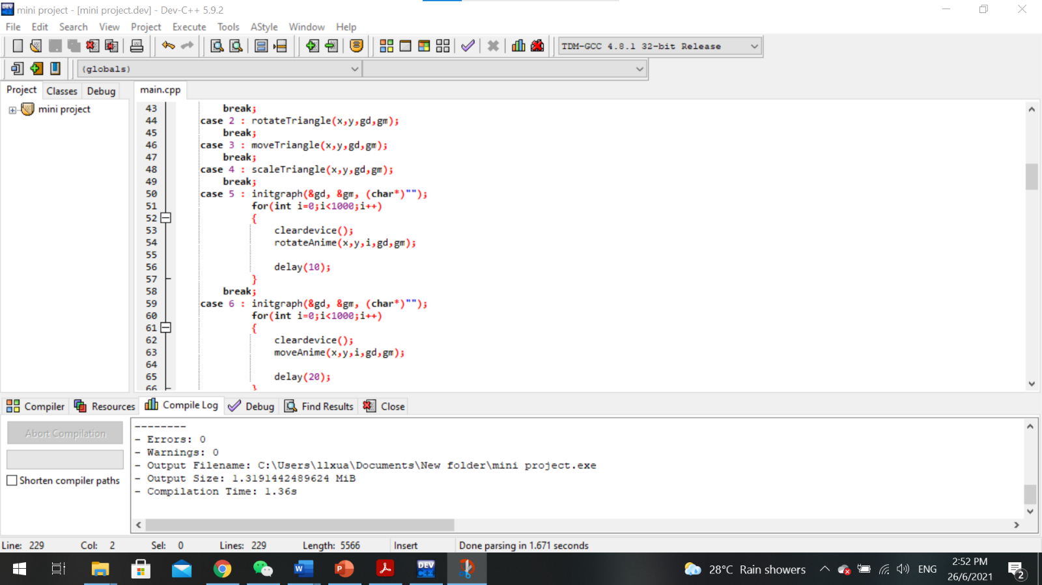

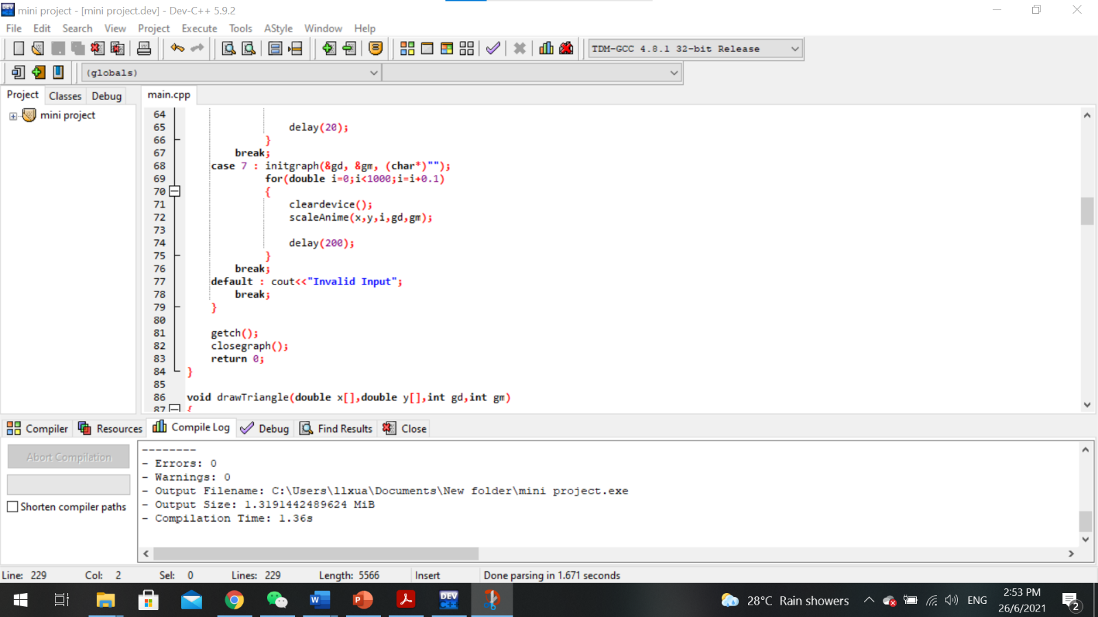

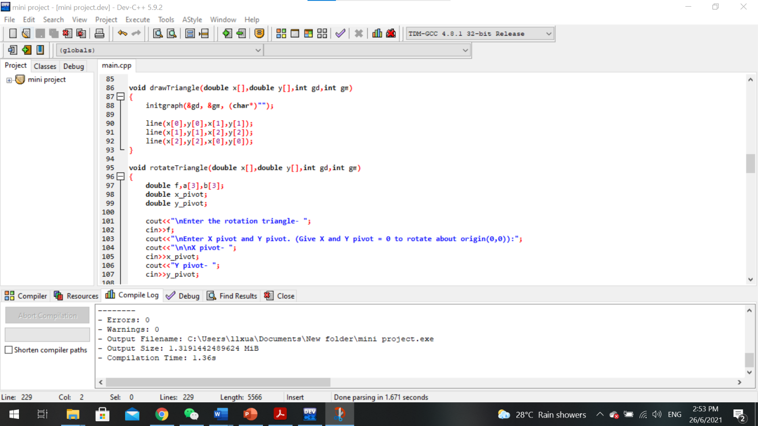

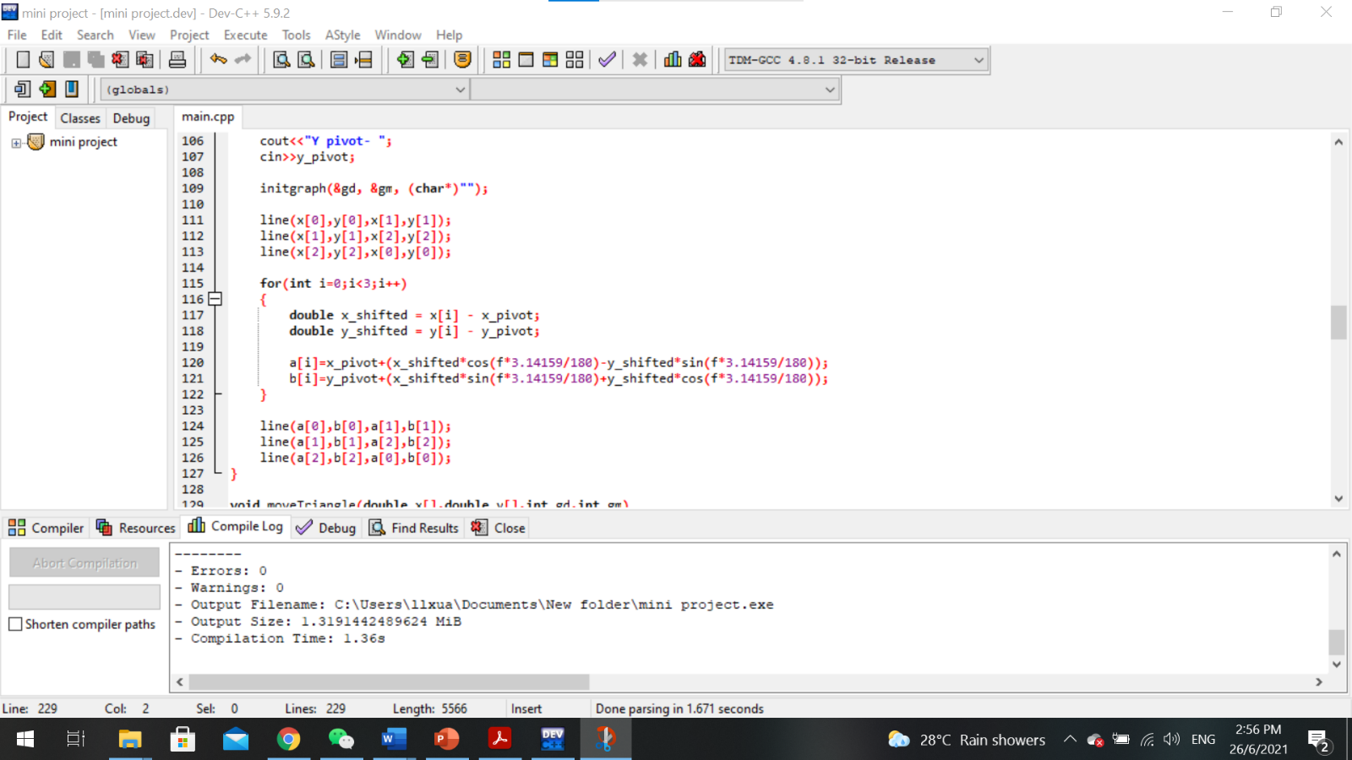

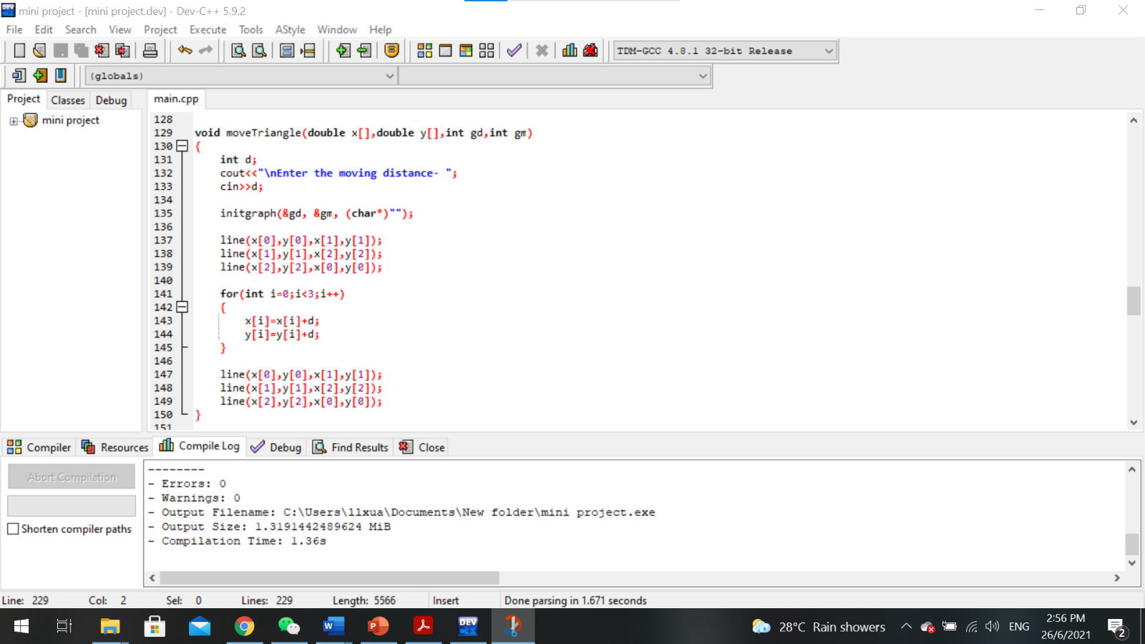

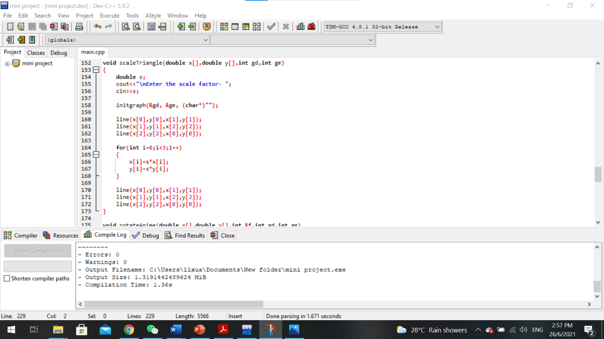

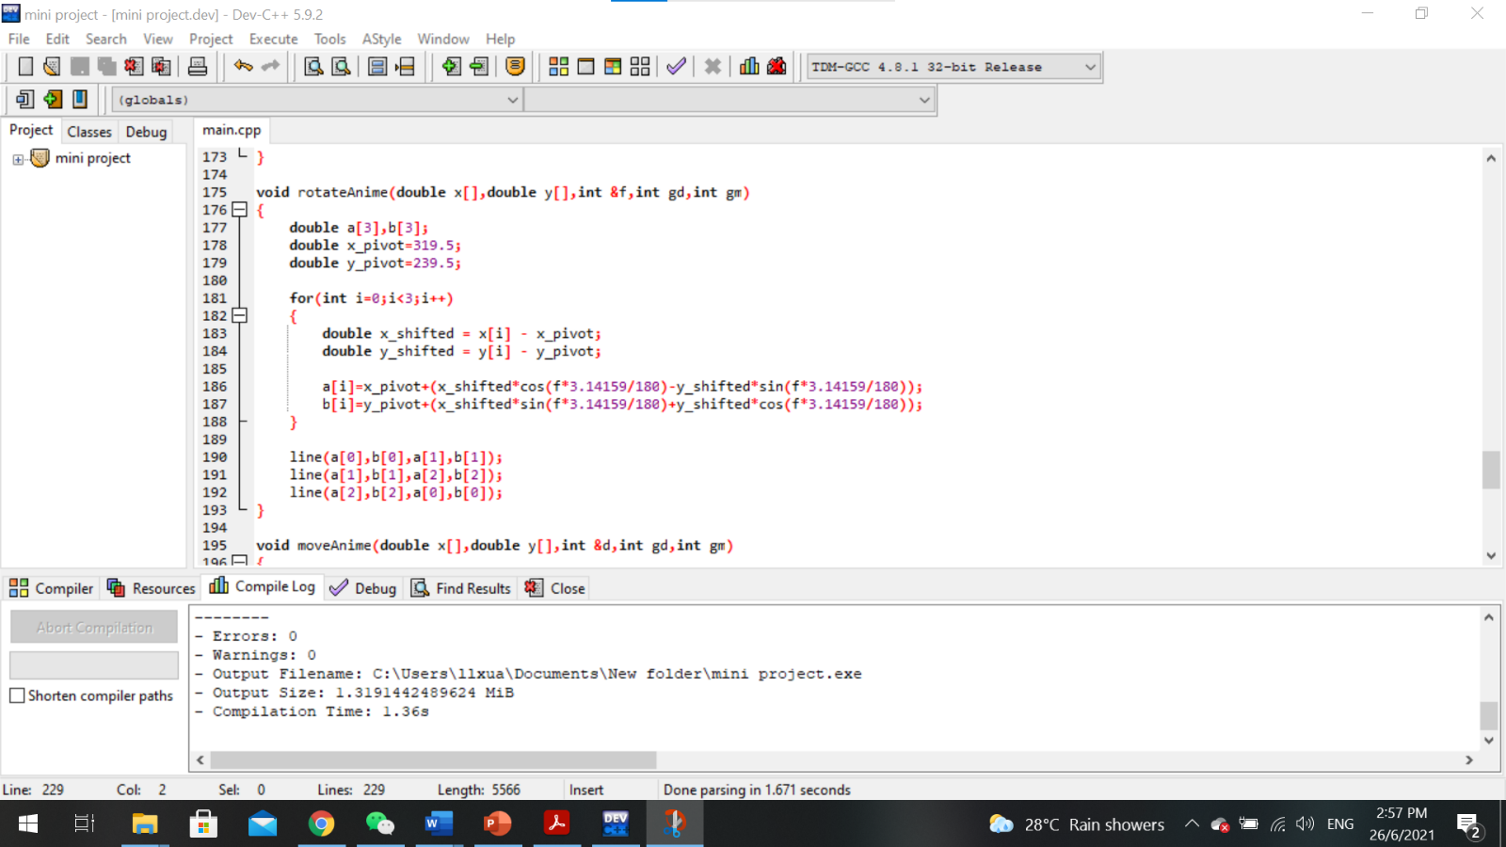

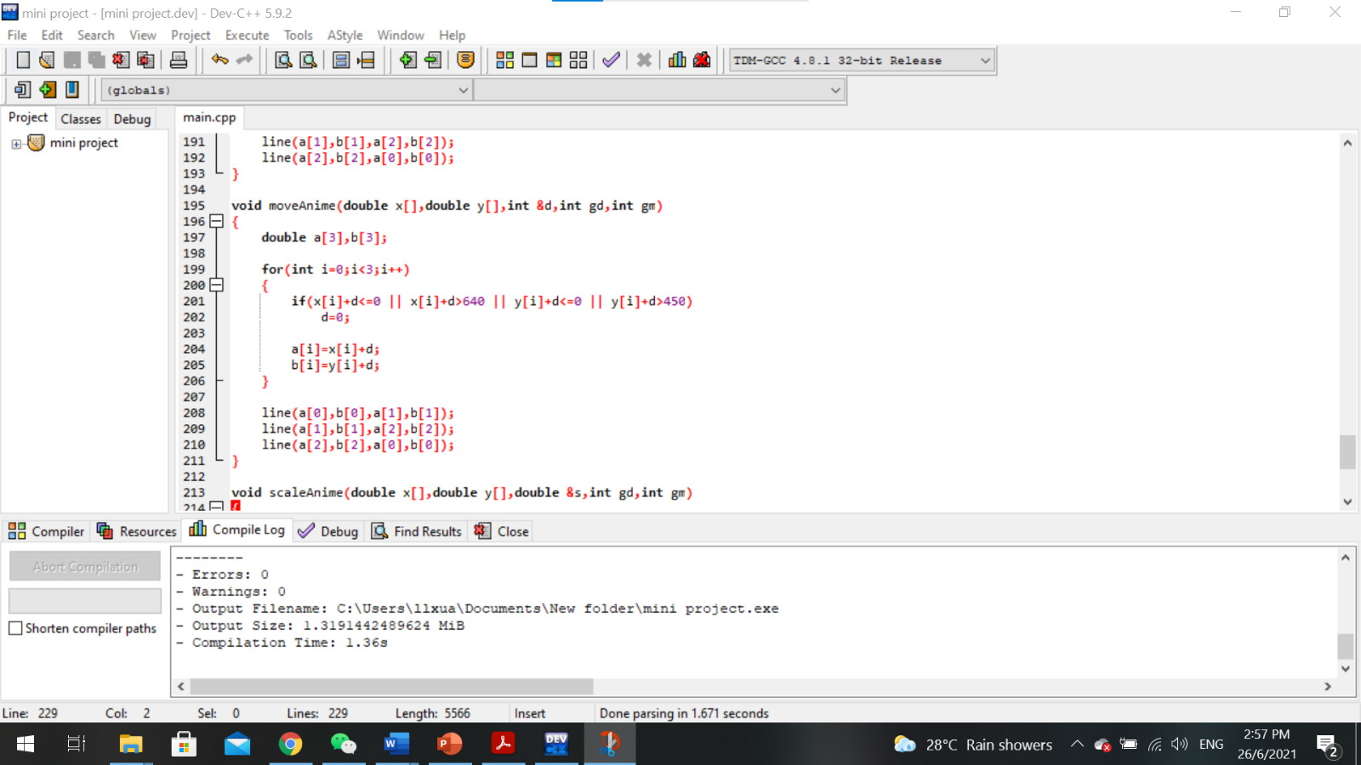

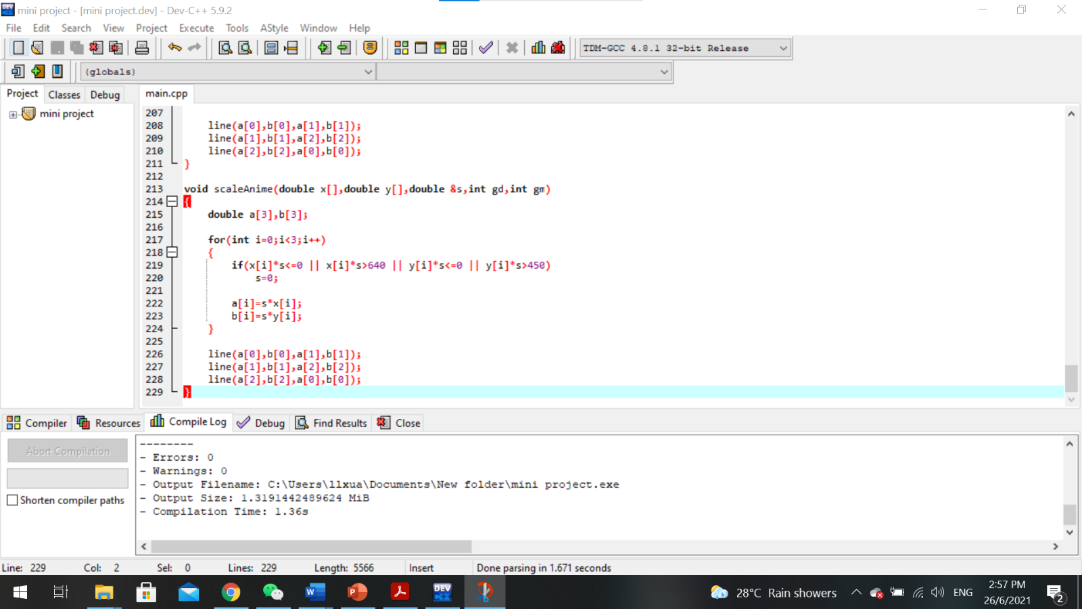

**Output Screenshots**

1. 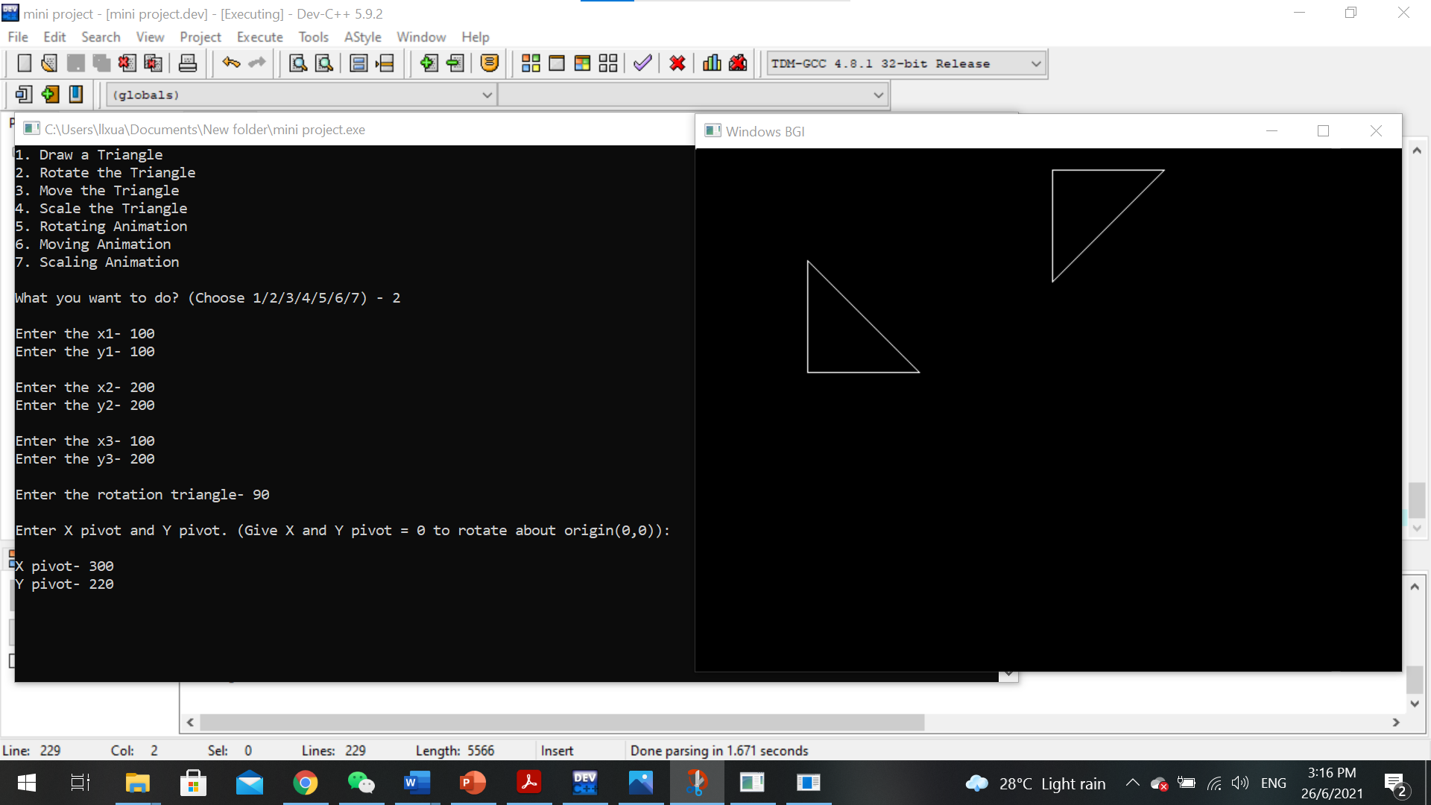Rotation

**2**

**1**

Triangle 1 is the object of rotation. Coordinates of Triangle 1’s vertices are stored in three matrices, they are A= $\left[\begin{aligned}x_{1} \\ y_{1}\end{aligned}\right]$ = $\left[\begin{aligned}100 \\ 100\end{aligned}\right]$, B= $\left[\begin{aligned}x_{2} \\ y_{2}\end{aligned}\right]$ = $\left[\begin{aligned}200 \\ 200\end{aligned}\right]$, C= $\left[\begin{aligned}x_{3} \\ y_{3}\end{aligned}\right]$ = $\left[\begin{aligned}100 \\ 200\end{aligned}\right]$. User is also prompted to input the centre of rotation so it is changed from (0,0) to a point about the centre of the window which is P= $\left[\begin{aligned}p_{x} \\ p_{y}\end{aligned}\right]$ = $\left[\begin{aligned}300 \\ 220\end{aligned}\right]$. This prevents the result of rotation from getting out of the window.

The original equation for calculating the image of rotation is $\left[\begin{aligned}{x^{'}}_{i} \\ {y^{'}}_{i}\end{aligned}\right]=\left[\begin{matrix}cos & -sin \\ sin & cos\end{matrix}\right].\left[\begin{aligned}x_{i} \\ y_{i}\end{aligned}\right].$ Since the centre of rotation is at P which is not (0,0), we need to use this equation to calculate the image of rotation, the original matrices are converted to homogenous matrices before using this formula. After calculating the rotation result of each vertex, Triangle 2(image) is constructed by linking all three points.

$\left[\begin{aligned}{x'}_{i} \\ {y'}_{i} \\ 1\end{aligned}\right]=\left[\begin{matrix}\cos{} & -sin & -p_{x}\left(cos\right)+p_{y}\left(sin\right)+p_{x} \\ sin & cos & -p_{x}\left(sin\right)-p_{y}\left(cos\right)+p_{y} \\ 0 & 0 & 1\end{matrix}\right]$*. $\left[\begin{matrix}x_{i} \\ y_{i} \\ 1\end{matrix}\right]$*

1. 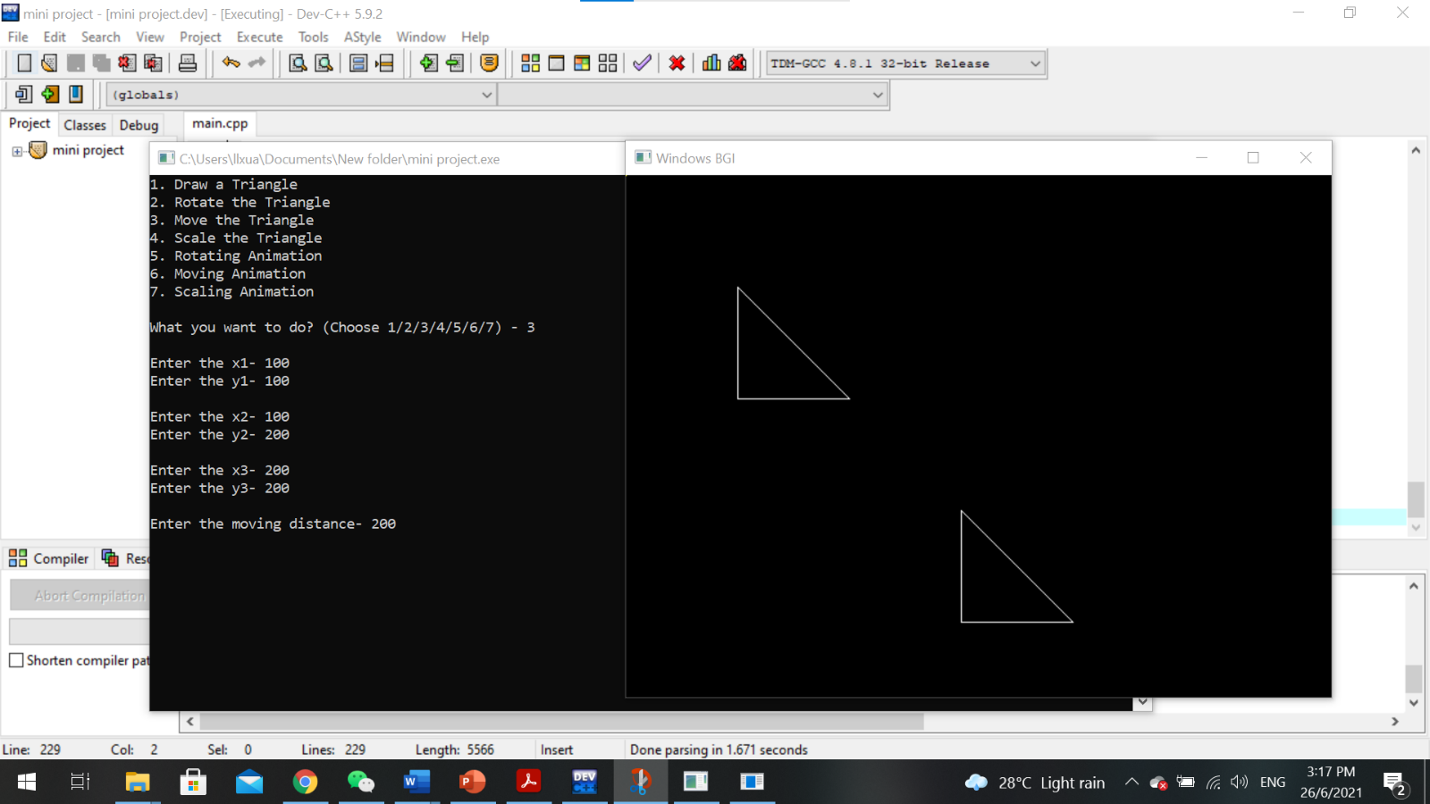Translation

**2**

**1**

Triangle 1 is the object of translation. Coordinate of Triangle 1’s vertices are stored in three matrices, they are A= $\left[\begin{aligned}x_{1} \\ y_{1}\end{aligned}\right]$ = $\left[\begin{aligned}100 \\ 100\end{aligned}\right]$, B= $\left[\begin{aligned}x_{2} \\ y_{2}\end{aligned}\right]$ = $\left[\begin{aligned}200 \\ 200\end{aligned}\right]$, C= $\left[\begin{aligned}x_{3} \\ y_{3}\end{aligned}\right]$ = $\left[\begin{aligned}100 \\ 200\end{aligned}\right]$. The moving distance is d= $d_{x}$ = $d_{y}$ =200, the matrix for the moving distance is D= $\left[\begin{aligned}d_{x} \\ d_{y}\end{aligned}\right]$ = $\left[\begin{aligned}200 \\ 200\end{aligned}\right]$. The image of the translation is calculated as $\left[\begin{aligned}{x'}_{i} \\ {y'}_{i}\end{aligned}\right]=\left[\begin{aligned}x_{i} \\ y_{i}\end{aligned}\right]+\left[\begin{aligned}d_{x} \\ d_{y}\end{aligned}\right]$. After calculating the translation result of each vertex, Triangle 2(image) is constructed by linking all three points.

1. Scaling

**2**

**1**

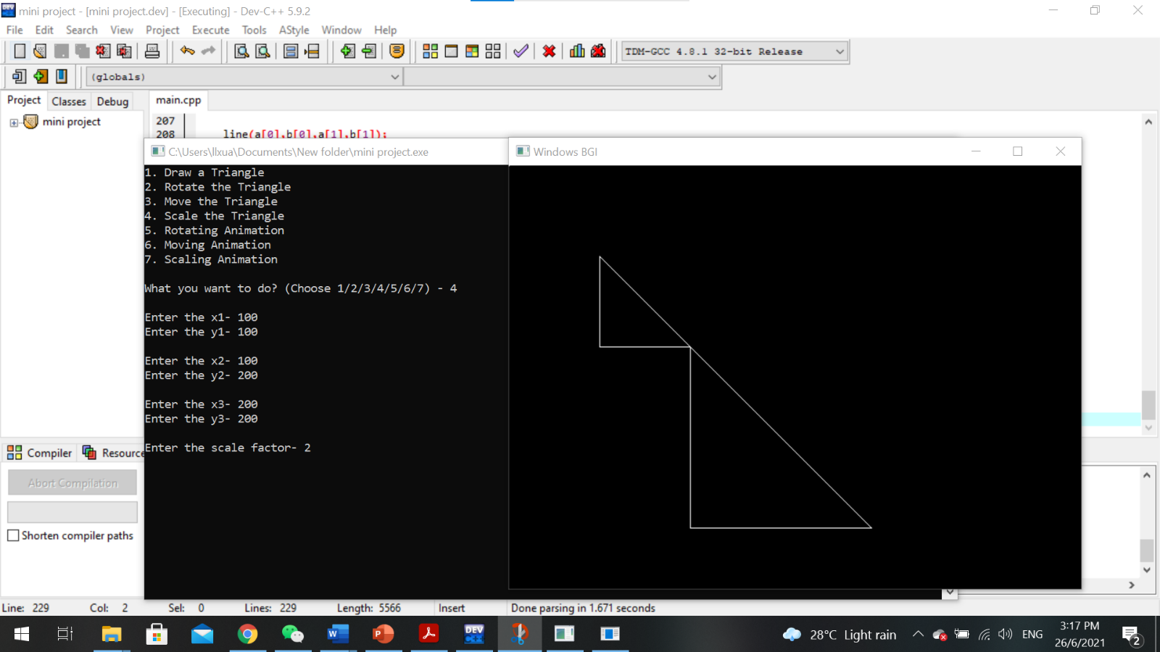

Triangle 1 is the object of translation. Coordinate of Triangle 1’s vertices are stored in three matrices, they are A= $\left[\begin{aligned}x_{1} \\ y_{1}\end{aligned}\right]$ = $\left[\begin{aligned}100 \\ 100\end{aligned}\right]$, B= $\left[\begin{aligned}x_{2} \\ y_{2}\end{aligned}\right]$ = $\left[\begin{aligned}200 \\ 200\end{aligned}\right]$, C= $\left[\begin{aligned}x_{3} \\ y_{3}\end{aligned}\right]$ = $\left[\begin{aligned}100 \\ 200\end{aligned}\right]$. The scaling factor is s = $s_{x}$ = $s_{y}$ =2, the matrix for the scaling factor is S = $\left[\begin{matrix}s_{x} & 0 \\ 0 & s_{y}\end{matrix}\right]$ = $\left[\begin{matrix}2 & 0 \\ 0 & 2\end{matrix}\right]$. The image of the translation is calculated as $\left[\begin{aligned}{x'}_{i} \\ {y'}_{i}\end{aligned}\right]=\left[\begin{aligned}x_{i} \\ y_{i}\end{aligned}\right]$. After calculating the translation result of each vertex, Triangle 2(image) is constructed by linking all three points.

**Conclusion**

We have learned the coordinate system, trigonometry, linear and non-linear equations, differentiation and integration, vectors, matrices, and planes in Mathematics of Computer Graphics. We defined the positions of each vertex of a triangle as coordinates and put each coordinate into a matrix to calculate the result of a transformation. In conclusion, the knowledge we learned in Mathematics of Computer Graphics has helped us creating this program.